[Simplified Study Title]

Information sheet for STUDENTS AGED 6 TO 10 YEARS

Ethics Approval Reference: [Insert]

My name is xxx and I work at the University of Oxford. I am doing some research and would like you, together with the rest of your [insert subject] class, to join in this study.
Research is a way people try to find out the answers to questions. I would like to see whether [the research aim/question should be given briefly here].
I have also written to your parents/guardians to tell them about this research and think about whether you should be included. Please talk to your parents about what you would like to do and, if you are unhappy, let me know.

Why have I been asked?
I am asking you if you would like to take part because you are in year [insert], studying [insert subject].
I am asking all the students in your class to help us.

Do I have to join in?
No you don’t have to if you don’t want to. You can ask questions before choosing whether you want to join in.
You can change your mind at any time by telling your teacher, the researcher or your parent/guardian. You don’t have to say why and this will not affect your education.
If you decide to stop, no one will be upset with you.
If you do not wish to join in, you will attend a different class/be seated where you cannot be observed/recorded. [delete as appropriate, or enter alternate provision]

What will happen?
This section should include very brief, easy to read statements covering:
How long the class will be involved in the research
What the students are being asked to do (questionnaire, tasks, video/audio recording etc.). Be clear that the teacher is the focus of the research;
Location of the study activities;
It may help if the information is displayed in a simple flowchart and/or using fun, child-friendly pictures.
Remember to use simple, non-frightening explanations for procedures

Example:
I was a teacher before I began my research. I will work as a classroom assistant in some of your lessons.
From the end of October until the end of March, I will come into lessons. I will make audio/video recordings of every lesson, focusing on your teacher. I will listen to and watch what your class do in lessons.
Your teacher will run the same lessons as usual and you will study in the same way as you are used to.

Will anything about the research upset me?
Simple, sensitive explanations are needed to prepare the student and you should say how their concerns/fears will be alleviated. Address any potential physical or emotional issues.

Will joining in help me?
The study will not help you but it might help other students in the future.

Will anyone else know I'm doing this?
The people in our research team will know you are taking part. No one will know that you have helped us with this research - unless, of course, you tell them yourself!

What happens to what the researchers find out?
When I collect information from you I will keep it in a safe place and only the people doing the research, or helping with the research, can look at it. I will use the information to [insert appropriate text here, e.g. where will the information be published?].

Is this study OK to do?
Before any research involving people happens, it has to be checked by a group of people known as a Research Ethics Committee to make sure that it is fair. The Ethics Committee at the University of Oxford has checked this study.

What do I do now?
Please tell your parents, guardians and teacher whether you are happy to take part.
I hope you will agree to take part in my study.

What if there is a problem or something goes wrong?
If you are not happy because of something that happened in the study, please talk to your parent/guardian/teacher, who will let the researcher know.

Thank you for reading – please ask me any questions.

Appendix – Sample images you may wish to use in the body of your PIS

 | 
 | 
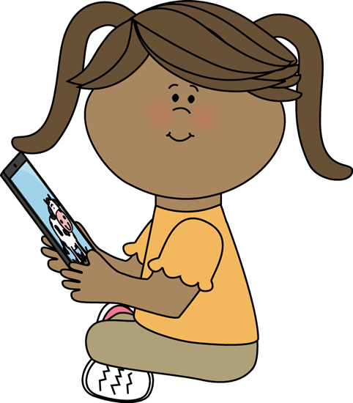 | 
 | 


