[Simplified Study Title]

Information sheet for CHILDREN aged 6 to 10 YEARS
To be shown and read by parent/guardian if required

Ethics Approval Reference: [Insert]

Our names are xxx and we work at the University of Oxford. We are doing some research and would like you to join in.
Research is a way we try to find out the answers to questions. We want to see whether [the research aim/question should be given briefly here].
You can talk to your family, friends, or the researchers if you want to before you agree to join in.

Why have I been asked?
We are asking you if you would like to take part because you are [between x and y years] old.
We are asking zzz [insert number of participants] children to help us.
Your parent/guardian has said it is OK for you to join in.

Do I have to join in?
No you don’t have to if you don’t want to! You can ask questions before choosing whether you want to join in.
You can change your mind at any time by telling the researcher or your parent/guardian. You don’t have to say why.
If you decide to stop, no one will be upset with you.

What will happen?
This section should include very brief, easy to read statements covering:
What the child is being asked to do (questionnaire, tasks, video/audio recording etc.) and how long this will take;
How many visits/interviews/tests etc. there will be and whether the child needs to miss any school;
Location of the study activities
It will help if the information is displayed in a simple flowchart and/or using fun, child-friendly pictures – see samples below.
Remember to use simple, non-frightening explanations for procedures

Will anything about the research upset me?
Simple, sensitive explanations are needed to prepare the child and you should also say how their concerns/fears will be alleviated. Address any potential physical or emotional issues.

Will joining in help me?
The study will not help you but it might help other children in the future.

Will anyone else know I'm doing this?
The people in our research team will know you are taking part. No one will know that you have helped us with this research - unless, of course, you tell them yourself!

What happens to what the researchers find out?
When we collect information from you we will keep it in a safe place and only the people doing the research, or helping with the research, can look at it. We will use the information to [insert appropriate text here, e.g. where will the information be published?].

Is this study OK to do?
Before any research involving people happens it has to be checked by a group of people known as a Research Ethics Committee to make sure that it is fair. This study has been checked by the Ethics Committee at the University of Oxford.

What if there is a problem or something goes wrong?
If you are not happy because of something that happened in the study, please talk to your parent/guardian who will let the researcher know.

Thank you for reading – please ask us any questions.

Appendix – Sample images you may wish to use in your PIS

 | 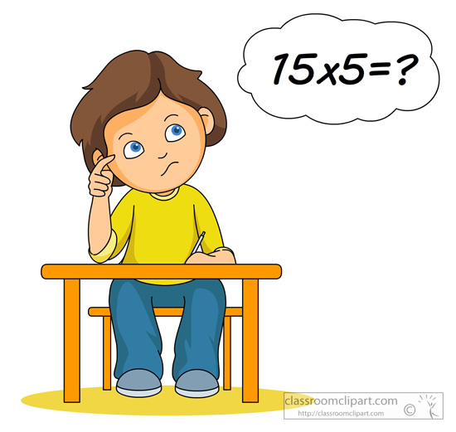
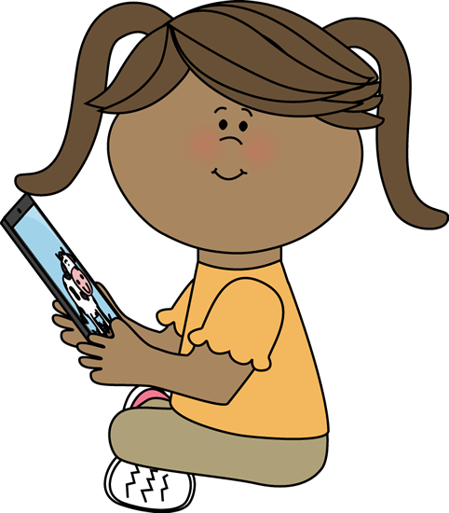
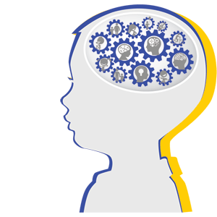 | 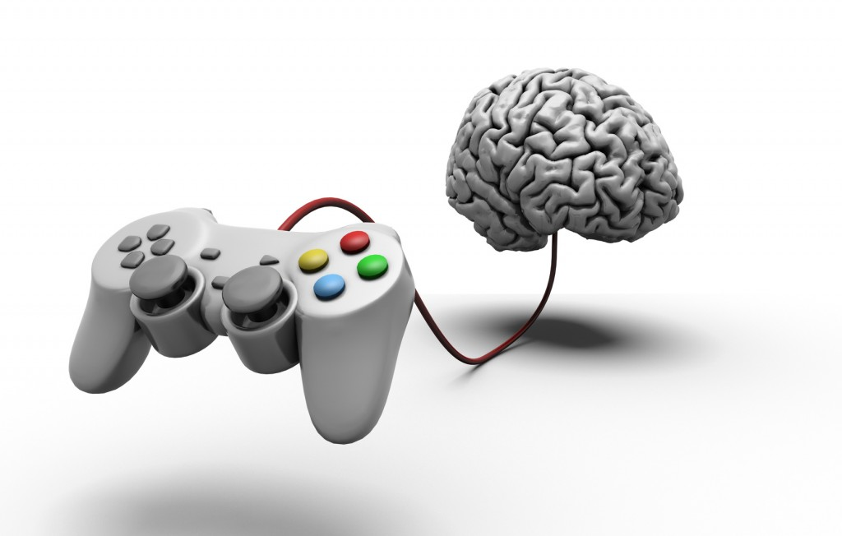
 | 