Instructions for downloading and/or printing IRAS Application Forms

1) During generation and editing of your application

From navigation pages  Select the required view (full dataset or a form) from the left column, The active view will is highlighted on the screen in blue – in this case full dataset. | 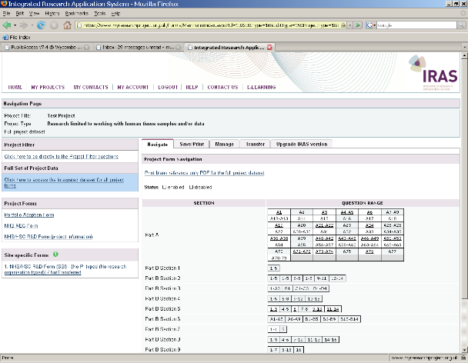
Select the Save/print tab and select from the choices give  i.e. Full BLANK form  or Your own form for review.  This ‘prints’ a copy of the required form to a pdf file.  You can also print a BLANK form from the navigation page. | 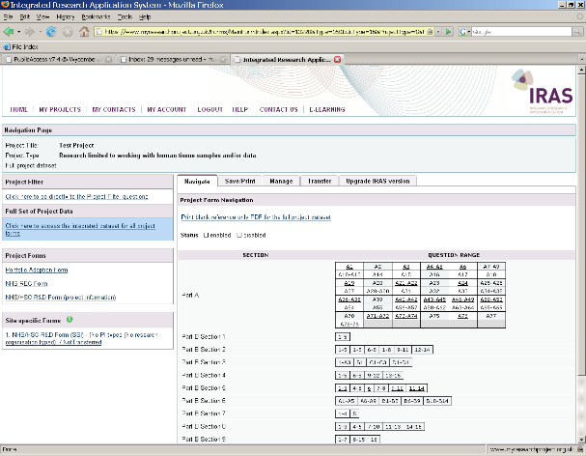
From form views  When you open any of the forms in IRAS there is a Print option towards the top left on every page. | 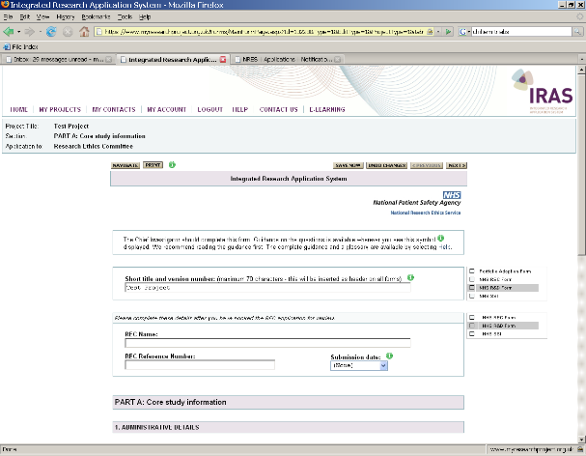
When you click on the in-form print button the following pop-up window will appear.  Select Print current page or Print all as required | 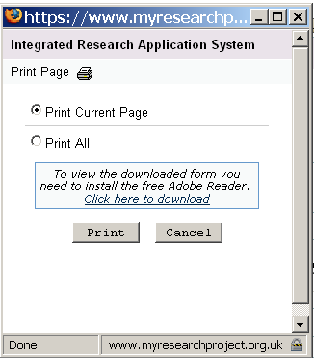

2) Submission

When you are ready to submit for approval select the required form  In this case the REC form has been selected (highlighted on the screen in blue). | 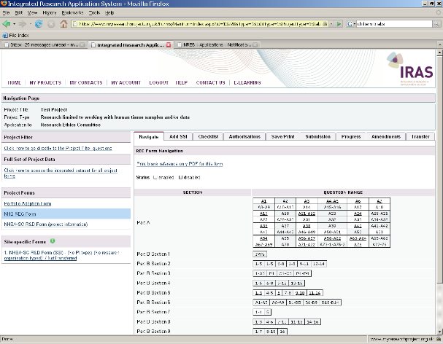
Select the Submission tab
Click on Proceed to Submission  IMPORTANT – this only generates pdfs it DOES NOT actually submit your form to a REC, you will need to send printed copies to the REC office  [See checklist tab for details of what to send to the REC office]  You can repeat the Proceed to Submission process up to the point of sponsor review. A list of all pdfs generated by this process can be found at the bottom of the screen. You cannot delete these so be careful to submit the latest one. Your sponsor letter will include the REC form reference code (lock code) which is given in this table and on the bottom right corner of every page of your final form. | 